How to install NFC on Sony Smartwatch 3
This is a guide to install NFC on your Sony Smartwatch 3. If anything goes wrong along the way, go to step 3 and start over.

Warning, following this guide will void your warranty

1. Install ADB (and Fastboot) on your computer
Below link works fine, will normally install to C:\adb
There are several guides how to do this, here is one: http://9to5google.com/2014/12/02/how-to-install-adb-tools-windows-mac-linux/
If this link doesn't work, just Google it.
2. Enable developer mode on your watch
2.1 On the watch goto "Settings -> About" and click on "Build number" until it says "You are now a developer".
2.2. Go to "Settings -> Developer options -> ADB debugging" and enable.
3. Check watch build number
3.1. On the watch go to "Settings -> About". Scroll down until you see "Build number". It will say something like LWX48F.
3.2. If it says "LCA43", you are lucky! Go to section 6.
3.3. If it starts with "M". Your version is too new and needs to be downgraded. Go to section 4.
3.4. If it starts with "L". Your version is too old and needs to be upgraded. Goto section 5.
4. Downgrade your version
4.1. This guide is based on http://forum.xda-developers.com/smartwatch-3/orig-development/tut-how-to-fix-swr50-fastboot-t3258918
4.2. Start by downloading all the files from https://drive.google.com/folderview?id=0B14BmzmcIZ4cVDBjRnliUDVXU1k&us p=drive_web
4.3. The files will all be in your Downloads folder (Windows user), move the files to C:\ADB folder.

4.4. Open up Command Prompt window (Type cmd in the start menu search box, right click cmd.exe under the Search results and Run As Administrator)
Navigate to the correct folder by typing - cd/adb (see pic below)

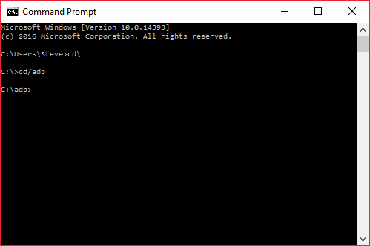
4.5. Plug phone into Pc
4.6. Now do a test
Type: adb devices
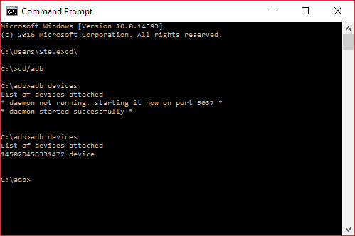
If this come back with no devices, or device is listed but unauthorised then you need to check the drivers on your PC and change them.
4.7. Right click My Computer/PC, Properties and then select Device Manager on Left Hand Menu.
4.8. At this point you should see Sony Smartwatch (Pic says Tetra but yours wont at this point) under other devices, double click and this will open the device properties

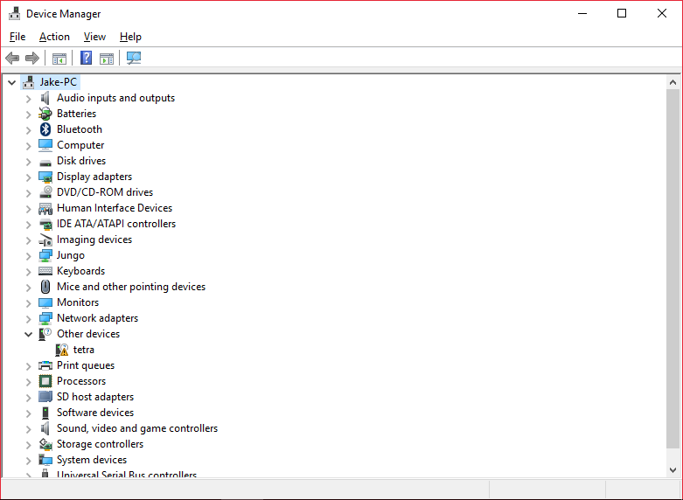

If you are not on an Admin Account then select Change Properties to enter Admin password.
4.9. You can now update drivers.
4.10. Go for the option to Browse My Computer

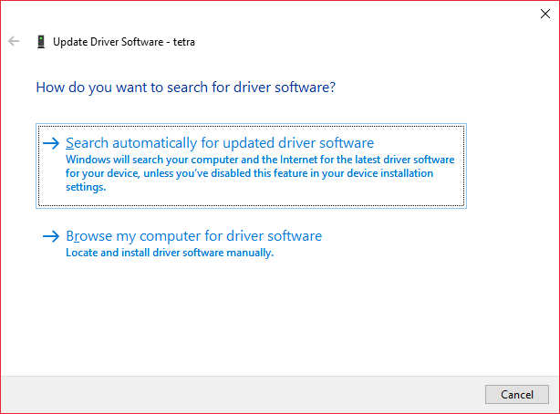

Then
4.11. Let me Pick from List of Drivers
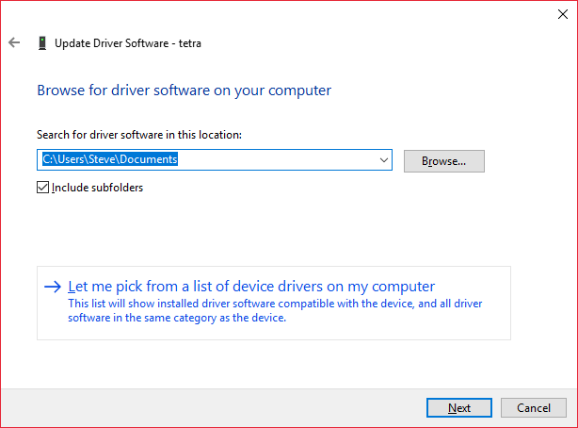

4.12. In the dropdown select Android Device 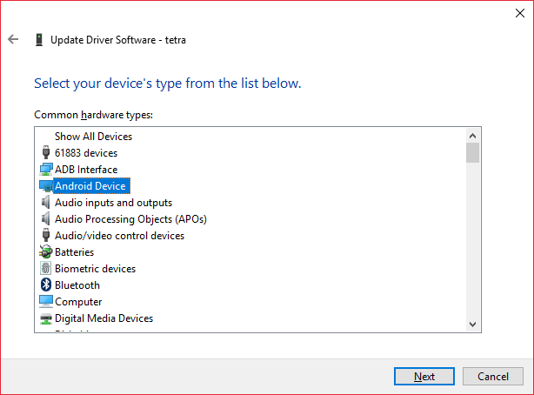

4.12. Choose either Google or Sony ADB Interface drivers.

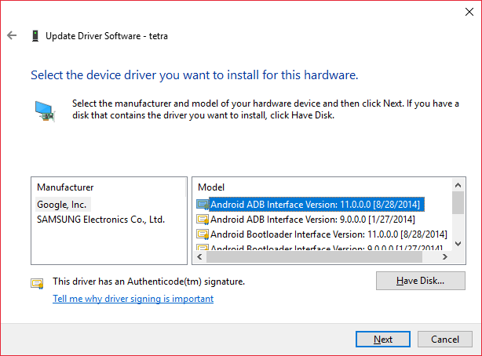
4.13. Click on next and complete driver install
4.14. Afterward, device manager should appear like this.
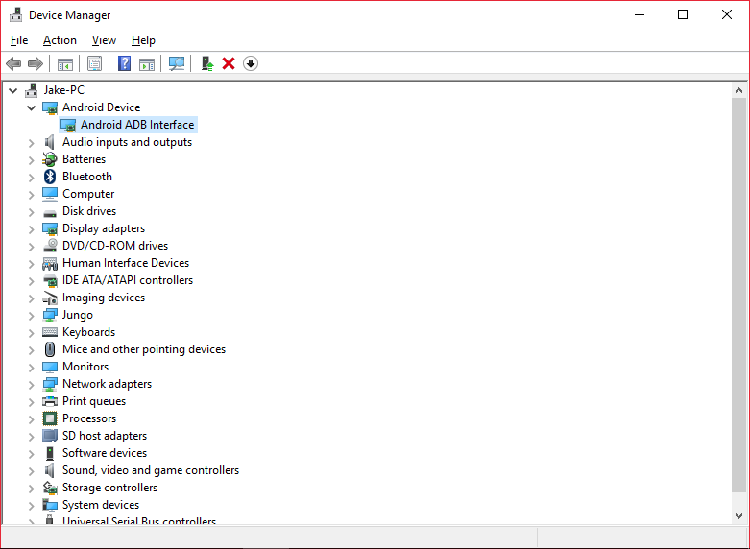

4.15. Now to restart watch to fastboot. In Command Prompt Window type each line below then hit enter and wait for C:\ADB to appear before proceeding to next line.

4.15.1. adb reboot bootloader
Wait until watch says "Running Fastboot"
4.15.2. fastboot oem unlock

At this point you will probably get the message ‘device waiting’. Hold down “CRTL” button and the letter “C” to quit
Again go to Devices, the SW3 now appears as a ‘tetra’ device, repeat steps 4.7 to 4.13 and update the Device driver to whichever ADB Interface is listed under Android Devices.
Type:
4.15.3. fastboot oem unlock
4.15.4. fastboot oem unlock (Yes, twice)
4.15.5 fastboot format cache

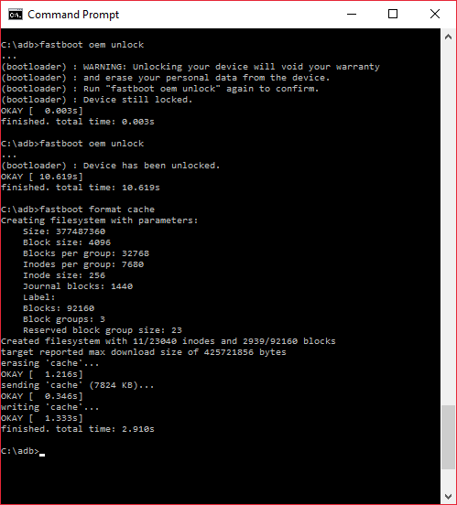

Type each line below then hit enter and wait for C:\ADB to appear before proceeding to next line.
Type:
4.15.6. fastboot format userdata
4.15.7. fastboot flash recovery SWR50.img
(that's one of the files you downloaded)
4.15.8. fastboot boot twrpnew.img
The phone will now reboot and you should see a menu on the watch. If it's stuck in boot sequence, goto ERR1 and then try "fastboot boot twrp.img".
Type:
4.15.9. adb push SWR50.zip /sdcard/

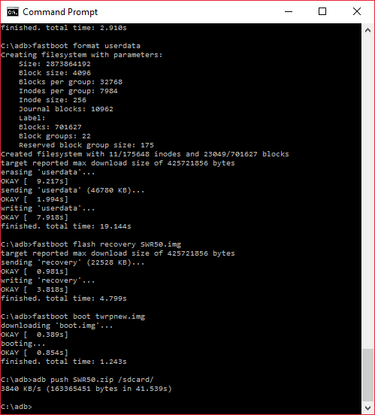

4.16. Press "Install" on the watch. Goto folder sdcard, press SWR50.zip and install.
4.17. After installation, press back. Goto "Wipe" and slide to factory reset.
4.18. Reboot device.
At this point the SW3 will sit waiting for you to install Android Wear on a phone. Note – this only works if you are using an Android phone to run Android Wear.

Redo step 2.

5. Install LCA43
Leave your SW3 plugged into the PC USB or plug back in if disconnected to fiddle with watch {This was what fixed my problem of the updates not installing at this point}

5.1. Go to Settings->About->System Update
This will start a download clock for the first update back up to LCA43 , if it says system up to date but not up to LCA43 do a factory reset and then try another system update.

5.2. Keep installing system updates until it says LCA43 under "Settings -> About -> Build number". You can see system update progress by going to "Settings -> About -> System updates".

6. Install NFC
6.1. Download file tetra_nfc_LCA43_0.2.zip from
http://forum.xda-developers.com/smartwatch-3/orig-development/sony-smartwatch-3-nfc-support-package-t3219713
6.2. Again copy these files to the c:\adb directory

In CMD Window type:

6.3. adb reboot bootloader
Now the watch should say "Running Fastboot".
Type:
6.4. fastboot oem unlock
6.5. fastboot oem unlock (Yes, twice)
6.6. fastboot boot twrpnew.img
6.7. adb push tetra_nfc_LCA43_0.2.zip /sdcard/

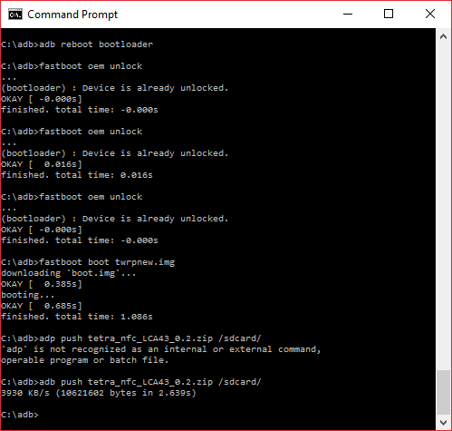

On the watch you should see a menu.
6.8. Press "Install" and locate the file under sdcard. Install it, then reboot.
6.9. If it boots, congratulations! Your watch now supports NFC!

If it doesn’t work, see below

Do not update the software if prompted by the watch at any time, otherwise you’ll have to go through the whole procedure again.

If it doesn't work, try to factory reset: First goto ERR1, after that write:
fastboot erase userdata
fastboot erase cache
fastboot reboot
If it still doesn't work, goto retry. Do step 4, 5, 6 again

ERR1. start fastboot
If you can't get to fastboot by running "adb reboot bootloader", do this:
1, Hold power button until watch turns off.
2, Unplug watch from computer.
3, Hold power button until a blue screen appear. DO NOT INSERT USB! (Yes, I know it tells you to)
4, Double press power button. Now the screen should say "Fastboot" with a black background.
5, Double press power button again. The screen should say "Running Fastboot" with a white background.
6, Plug it back to the computer

